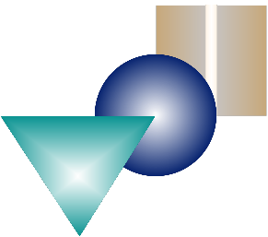
A Piece of Your Mind: Brain Anatomy
The Brain: It’s All In Your Mind
Student Pages Activity 1A

Introduction:
Today you will learn about the different structures of the human brain. The brain is a very complex organ made up of millions, if not billions of cells. The average human brain is nearly three-pounds and fills most of the top half of your head and is roughly the size of a coconut fruit.

Background:
The Brain and Its Parts
The brain may be divided into many parts, but for the purpose of this unit, four main parts will be defined. They are referred to as the Cerebrum, Diencephalon, Cerebellum, and Brain Stem. Even though they are part of one organ, they function differently and work together to control body activities. It is important to remember that each part of the brain
is responsible for controlling a specific combination of activities within the body. An example of parts of the brain controlling at the same time would be the cerebrum and the cerebellum. The cerebrum controls processes that require conscious thought, sensation, and voluntary movement. The cerebellum regulates balance and coordination; both processes may occur at the same time.

Cerebrum —
The Cerebrum is the largest area of our brain. It makes up almost two-thirds of the volume
of the total brain. The outward appearance of the cerebrum has a wrinkled surface. This “wrinkling” allows for a greater surface area so that more nerve cells (neurons) can fit into a smaller space. (Think about wrinkling a sheet of paper - the 8 1/2” X 11” page fits in a much smaller space after crumpling it.) This makes more neurons available for the complex human nervous system to do its work. The outermost layer of the cerebrum is called the cerebral cortex. The cerebral cortex is only 1/4 inch thick. It covers the wrinkled surface of the cerebrum like the bark of a tree. High-level human functions such as thought, memory, emotions, personality, voluntary movement and reasoning are controlled here. The cerebrum is divided into two halves, called hemispheres. The hemispheres are divided by
a deep split, but the two halves communicate with each other and the rest of the brain through a network of connecting nerve tissue. Each hemisphere is divided into 5 lobes. Four of these lobes are easily studied because they are located on the surface of the cortex.
1. Frontal Lobe: responsible for thinking and creativity. The motor area is located within the frontal lobe. (#1 in the diagram)
1a. At the back of the frontal lobe is an area that controls motor functions.
2. Parietal Lobe: regulates memory of objects and their uses, and directions.
Also located in this lobe is the sensory area, which receives many of the
fibers that connect the two halves of the cerebellum to the brain stem. The
name “pons” means Bridge as it is a bridge to these parts of the brain. The pons plays
an important role in connecting the cerebellum with the rest
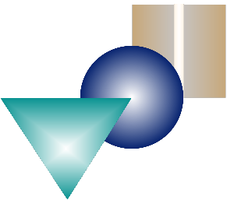
2a. At the front of the parietal lobe is an area that controls sensory functions.
The Brain: It’s All In Your Mind
3. Temporal Lobe: controls hearing, speech, and memory
(#3 in the diagram)
4. Occipital Lobe: nerve impulses from the eyes are received, where the brain translates them into images. (#4 in the diagram)
5. Insular Lobe: this lobe is located beneath the other four lobes, and cannot be seen without pushing aside the frontal and temporal lobes. Scientists are not sure what are controlled by this lobe. Some studies have been done that indicate it is related to controlling behavior related to feelings of pleasure. (#5 in the diagram-under the flap)
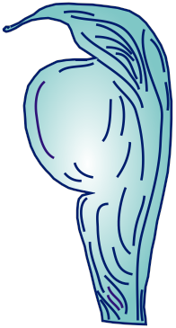
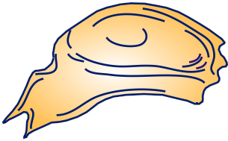
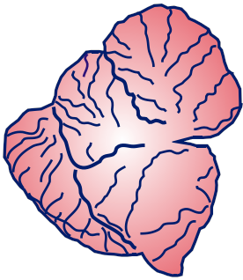
Cerebellum —
The cerebellum, or “little brain”, is similar to the cerebrum in its
external appearance. It has two hemispheres and is folded on the surface or cortex. This structure is associated with regulation and coordination of movement, posture, and balance. It is also believed to play a role in learning (cognitive) development. It is located below the rear part of the cerebrum, right behind the brainstem. (#6 in the diagram)
Diencephalon —
The diencephalon is located below the two hemispheres of the
cerebrum and above the brain stem. This area of the brain can be divided into two major parts, the thalamus and hypothalamus.
The thalamus is associated with transmitting sensory impulses and the hypothalamus is associated with maintaining homeostasis (balance) in the body by controlling temperature, sleep, appetite, and some emotions. (#7 in the diagram)
Brain Stem —
The brain stem is located below the diencephalon and connects to
the spinal cord, which if found inside the vertebrae of the spine. It can be divided into three structural parts that include the mid- brain, pons, and medulla oblongata. (#8 in the diagram)
1. Midbrain: This area forms the upper part of the brain stem and functions to control and regulate various reflex
actions such as those involved in the eyes, such as in the process of reading.
(#8-1 in the diagram)
2. Pons: This area is located below the midbrain and is composed of nerve

of the nervous system, and is vital for integrating such involuntary actions as breathing. (#8-2 in the diagram)
The Brain: It’s All In Your Mind
3. Medula Oblongata: Located below the Pons, this region of the brain stem directly connects to the spinal cord. It contains a collection of nerve fibers that include motor fibers extending from the cerebrum.
These fibers cross each other in this area of the brain stem and results in the right half of the brain controlling the left side of the body and the left
half of the brain controlling the right side of the body. The Medulla Oblongata contains vital clusters of nerves involved in respiration, heartbeat and blood pressure. (#8-3 in the diagram)

